DTSC 671: AI Solutions in the Cloud

SUBMISSION TEMPLATE:
Text Extraction with Amazon Textract

Select File > Make a copy to edit the template and add your screenshots. Download the completed template as a PDF document to submit to Brightspace.

In every screenshot, include your AWS username that appears in the upper right corner. Example:

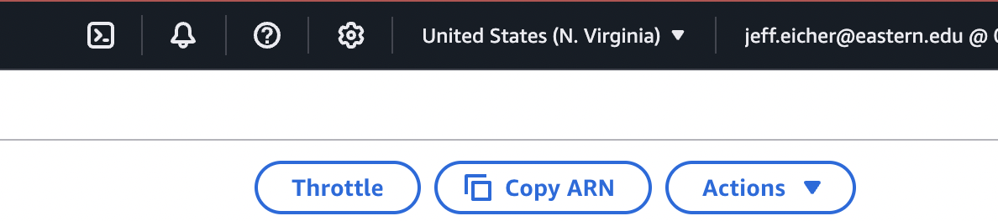

If any one screenshot is missing this identification, the entire assignment will be scored no higher than 70%.

Points totals are provided at the start of each question. You score either full credit or 0 points; there is no partial credit for each question.

Curtis Nielson
DTSC-671

- [10 points] In the space below, provide a screenshot of the Lambda function diagram (with trigger and destination).

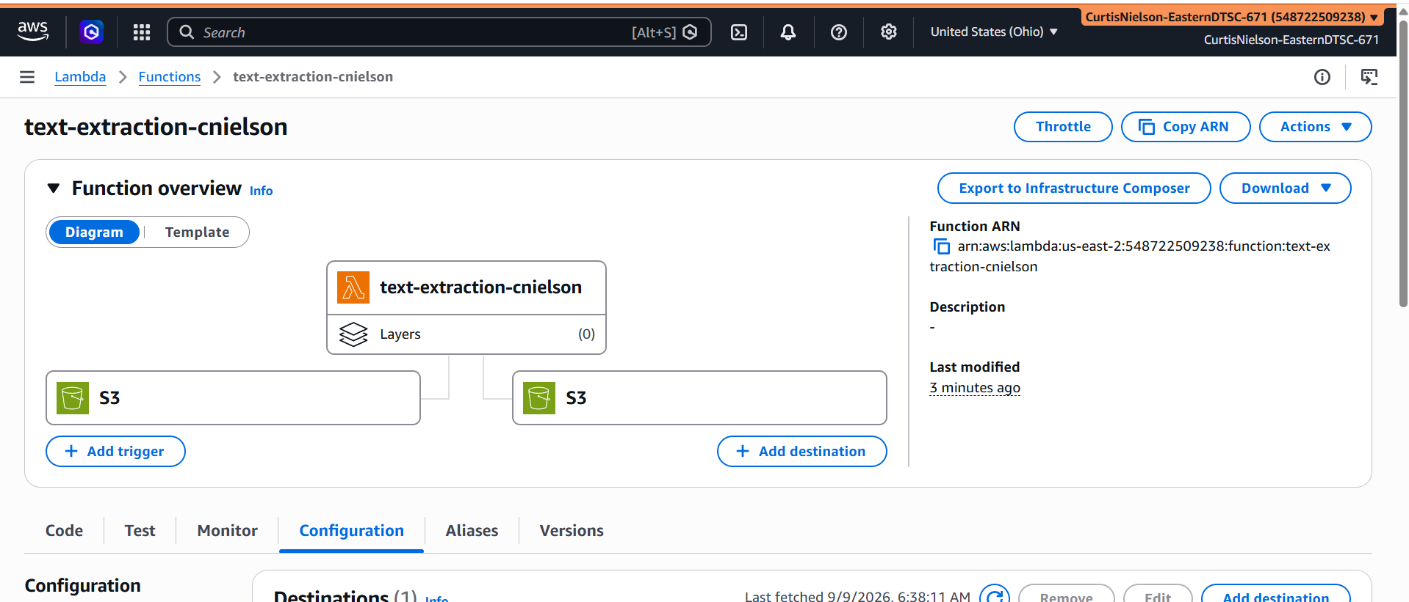
- [10 points] In the space below, provide both a screenshot of the beginning of your Lambda code with your account showing, then copy-paste your full lambda code below the screenshot. Note: when writing your function be sure that your code picks up only the skills in the resume, not the symbols ( | or - ).
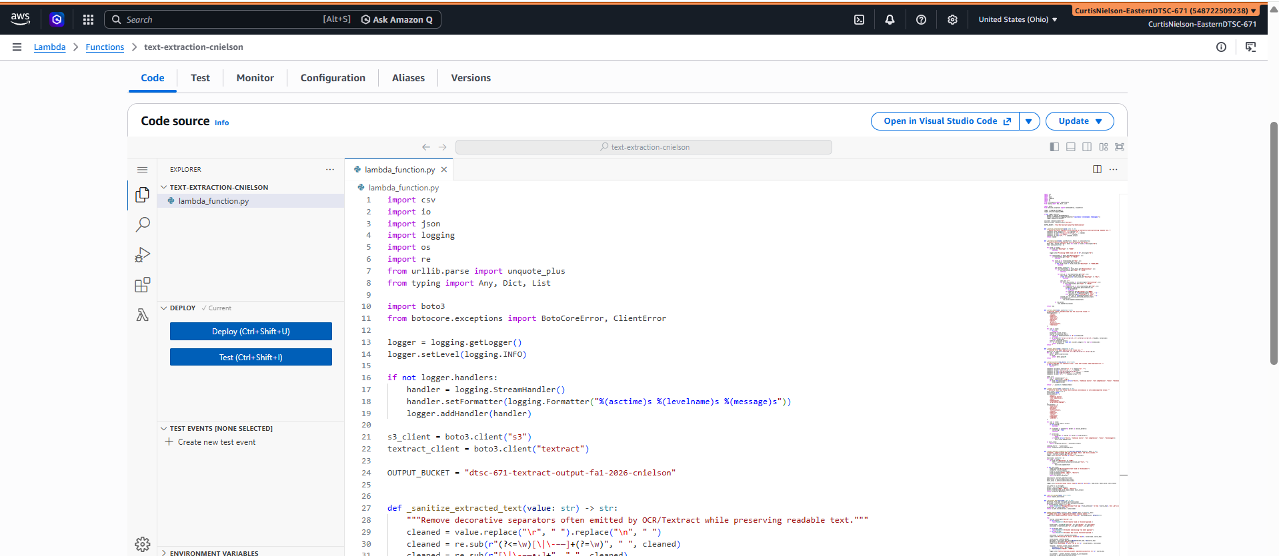

import csv
import io
import json
import logging
import os
import re
from urllib.parse import unquote_plus
from typing import Any, Dict, List

import boto3
from botocore.exceptions import BotoCoreError, ClientError

logger = logging.getLogger()
logger.setLevel(logging.INFO)

if not logger.handlers:
handler = logging.StreamHandler()
handler.setFormatter(logging.Formatter("%(asctime)s %(levelname)s %(message)s"))
logger.addHandler(handler)

s3_client = boto3.client("s3")
textract_client = boto3.client("textract")

OUTPUT_BUCKET = "dtsc-671-textract-output-fa1-2026-cnielson"

def _sanitize_extracted_text(value: str) -> str:
"""Remove decorative separators often emitted by OCR/Textract while preserving readable text."""
cleaned = value.replace("\r", " ").replace("\n", " ")
cleaned = re.sub(r"(?<=\w)[\|\-–—]+(?=\w)", " ", cleaned)
cleaned = re.sub(r"[\|\-–—•·]+", " ", cleaned)
cleaned = re.sub(r"\s+", " ", cleaned).strip()
return cleaned

def _get_table_rows(blocks: List[Dict[str, Any]]) -> List[List[str]]:
"""Convert Textract TABLE blocks into row-oriented CSV values."""
block_map = {block.get("Id"): block for block in blocks if block.get("Id")}
rows: List[List[str]] = []

for block in blocks:
if block.get("BlockType") != "TABLE":
continue

logger.info("Processing TABLE block with ID %s", block.get("Id"))

for relationship in block.get("Relationships", []):
if relationship.get("Type") != "CHILD":
continue

for child_id in relationship.get("Ids", []):
child_block = block_map.get(child_id)
if not child_block or child_block.get("BlockType") != "TABLE_ROW":
continue

row_values: List[str] = []
for row_relationship in child_block.get("Relationships", []):
if row_relationship.get("Type") != "CHILD":
continue

for cell_id in row_relationship.get("Ids", []):
cell_block = block_map.get(cell_id)
if not cell_block or cell_block.get("BlockType") != "CELL":
continue

cell_text = ""
for cell_relationship in cell_block.get("Relationships", []):
if cell_relationship.get("Type") != "CHILD":
continue
for grandchild_id in cell_relationship.get("Ids", []):
grandchild = block_map.get(grandchild_id)
if not grandchild:
continue
if grandchild.get("BlockType") == "WORD":
cell_text += f"{grandchild.get('Text', '')} "
elif grandchild.get("BlockType") == "LINE":
cell_text += f"{grandchild.get('Text', '')} "
cleaned_text = _sanitize_extracted_text(cell_text)
if cleaned_text:
row_values.append(cleaned_text)

if row_values:
rows.append(row_values)

return rows

def _extract_name(lines: List[str]) -> str:
"""Find the likely candidate name near the top of the resume."""
heading_markers = {
"contact",
"summary",
"objective",
"experience",
"education",
"skills",
"projects",
"certifications",
"references",
}

for line in lines:
if not line:
continue
normalized = line.strip()
lowered = normalized.lower()
if lowered in heading_markers or "@" in normalized:
continue
if re.fullmatch(r"[A-Za-z][A-Za-z'’.-]+(?:\s+[A-Za-z][A-Za-z'’.-]+){1,5}", normalized):
return normalized
tokens = normalized.split()
if 2 <= len(tokens) <= 6 and not any(char.isdigit() for char in normalized):
return normalized
return ""

def _extract_email(lines: List[str]) -> str:
"""Find the first email address in the resume text."""
pattern = re.compile(r"[A-Za-z0-9._%+\-]+@[A-Za-z0-9.-]+\.[A-Za-z]{2,}")
for line in lines:
match = pattern.search(line)
if match:
return match.group(0)
return ""

def _normalize_skills(raw_skills: str) -> str:
"""Convert OCR/PDF list separators into a clean CSV-friendly comma-separated list."""
if not raw_skills:
return ""

cleaned = raw_skills.replace("\r", " ").replace("\n", " ")
cleaned = re.sub(r"\s*[,;|/]+\s*", ", ", cleaned)
cleaned = re.sub(r"\s*[-–—]+\s*(?=[A-Za-z0-9])", ", ", cleaned)
cleaned = re.sub(r"\s*•\s*|\s*·\s*", ", ", cleaned)
cleaned = re.sub(r"\s+", " ", cleaned).strip(" ,;")

items = []
for item in cleaned.split(","):
value = item.strip(" -|;•·/")
if value and value.lower() not in {"skills", "technical skills", "core competencies", "tools", "technologies"}:
items.append(value)

return ", ".join(dict.fromkeys(items))

def _extract_skills(lines: List[str]) -> str:
"""Extract a skill list from a skills section and normalize it into comma-separated values."""
skill_lines: List[str] = []
collecting = False
section_markers = {
"skills",
"technical skills",
"core competencies",
"tools",
"technologies",
"programming languages",
}
stop_markers = {
"experience",
"education",
"projects",
"certifications",
"summary",
"objective",
"contact",
"references",
"languages",
"interests",
}

for line in lines:
lowered = line.lower().strip()
if not lowered:
continue

if any(marker in lowered for marker in section_markers):
collecting = True
continue

if collecting:
if any(marker in lowered for marker in stop_markers):
break
if lowered not in {"skills", "technical skills", "core competencies", "tools", "technologies"}:
skill_lines.append(line)

if skill_lines:
return _normalize_skills(" ".join(skill_lines))

combined_text = " ".join(lines)
return _normalize_skills(combined_text)

def _convert_textract_response_to_csv(textract_response: Dict[str, Any]) -> str:
"""Create a compact resume CSV with only Name, Email, and Skills columns."""
blocks = textract_response.get("Blocks", [])
logger.info("Textract returned %s blocks", len(blocks))

text_lines: List[str] = []
for block in blocks:
if block.get("BlockType") == "LINE":
text = _sanitize_extracted_text(block.get("Text", ""))
if text:
text_lines.append(text)

if not text_lines:
logger.warning("No extractable text found in the document.")
csv_buffer = io.StringIO()
writer = csv.writer(csv_buffer)
writer.writerow(["Name", "Email", "Skills"])
writer.writerow(["", "", ""])
return csv_buffer.getvalue()

name_value = _extract_name(text_lines)
email_value = _extract_email(text_lines)
skill_value = _extract_skills(text_lines)

logger.info("Extracted resume fields: name=%s email=%s skills=%s", name_value, email_value, skill_value)

csv_buffer = io.StringIO()
writer = csv.writer(csv_buffer)
writer.writerow(["Name", "Email", "Skills"])
writer.writerow([name_value, email_value, skill_value])
return csv_buffer.getvalue()

def _safe_url_decode(value: str) -> str:
return unquote_plus(value)

def _get_output_key(source_key: str) -> str:
directory, file_name = os.path.split(source_key)
base_name, file_extension = os.path.splitext(file_name)
if file_extension.lower() != ".pdf":
raise ValueError(f"Unsupported input file type '{file_extension}' for key '{source_key}'. Only .pdf is supported.")
output_name = f"{base_name}.csv"
return os.path.join(directory, output_name)

def lambda_handler(event: Dict[str, Any], context: Any) -> Dict[str, Any]:
"""Lambda entry point triggered by S3 object creation events."""
logger.info("Lambda invocation started. Event=%s", json.dumps(event, default=str))

try:
records = event.get("Records", [])
if not records:
raise ValueError("No S3 records found in the event payload.")

bucket_name = records[0].get("s3", {}).get("bucket", {}).get("name")
source_key = records[0].get("s3", {}).get("object", {}).get("key")

if not bucket_name:
raise ValueError("S3 bucket name missing from event payload.")
if not source_key:
raise ValueError("S3 object key missing from event payload.")

source_key = _safe_url_decode(source_key)
logger.info("Processing S3 object: bucket=%s key=%s", bucket_name, source_key)

target_bucket = OUTPUT_BUCKET
pdf_object = s3_client.get_object(Bucket=bucket_name, Key=source_key)
pdf_bytes = pdf_object["Body"].read()
logger.info("Downloaded %s bytes from S3 for %s", len(pdf_bytes), source_key)

response = textract_client.analyze_document(
Document={"Bytes": pdf_bytes},
FeatureTypes=["TABLES", "FORMS"],
)
logger.info("Textract analyze_document completed successfully for %s", source_key)

csv_content = _convert_textract_response_to_csv(response)
output_key = _get_output_key(source_key)

s3_client.put_object(
Bucket=target_bucket,
Key=output_key,
Body=csv_content.encode("utf-8"),
ContentType="text/csv",
)

logger.info(
"CSV uploaded successfully to S3 bucket=%s key=%s",
target_bucket,
output_key,
)

return {
"statusCode": 200,
"body": json.dumps(
{
"message": "PDF processed successfully via Amazon Textract.",
"sourceBucket": bucket_name,
"sourceKey": source_key,
"outputBucket": target_bucket,
"outputKey": output_key,
}
),
}

except (ClientError, BotoCoreError) as exc:
logger.exception("AWS SDK error while processing S3/Textract request: %s", exc)
return {
"statusCode": 500,
"body": json.dumps({"error": "AWS service error", "details": str(exc)}),
}
except ValueError as exc:
logger.exception("Validation error: %s", exc)
return {
"statusCode": 400,
"body": json.dumps({"error": "Validation error", "details": str(exc)}),
}
except Exception as exc: # pragma: no cover - final safety net
logger.exception("Unexpected error occurred in Lambda handler: %s", exc)
return {
"statusCode": 500,
"body": json.dumps({"error": "Unexpected processing error", "details": str(exc)}),
}

- [10 points] In the space below, provide a screenshot of the CloudWatch log streams for your Lambda function. Fit as many as you can in the screenshot.

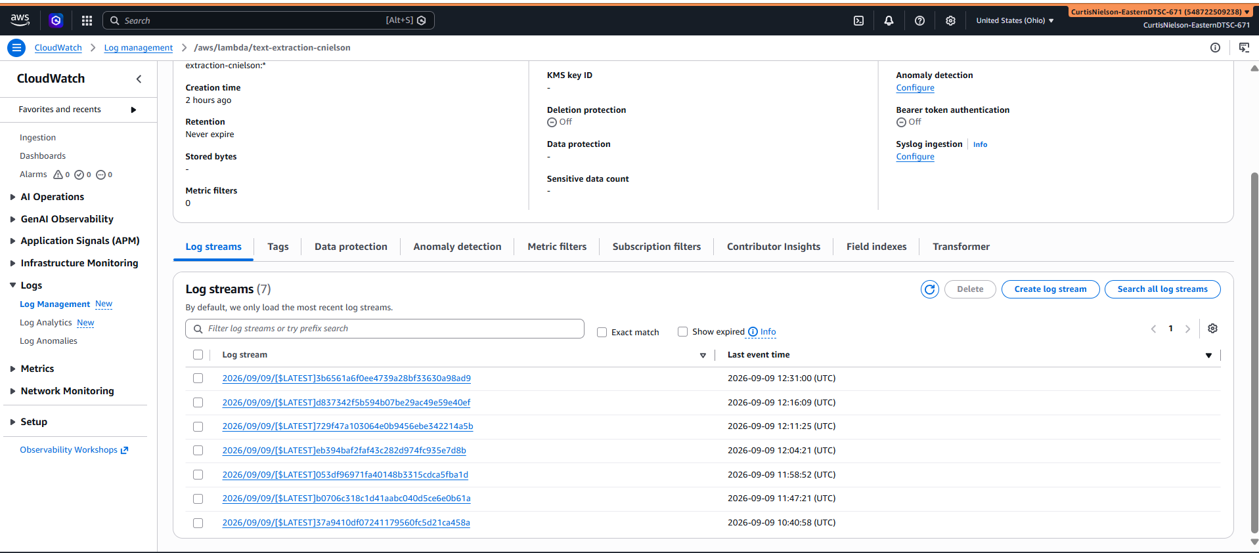

- [10 points] In the space below, provide a screenshot of the CloudWatch stream that functioned without errors.

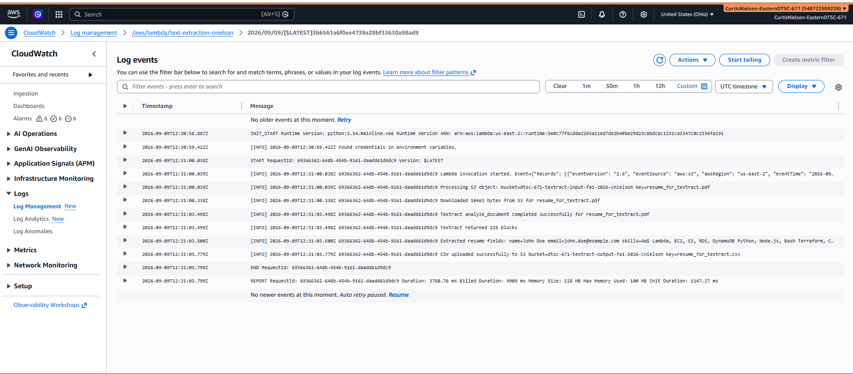

- [10 points] In the space below, provide a screenshot of IAM role permissions for the Lambda function.
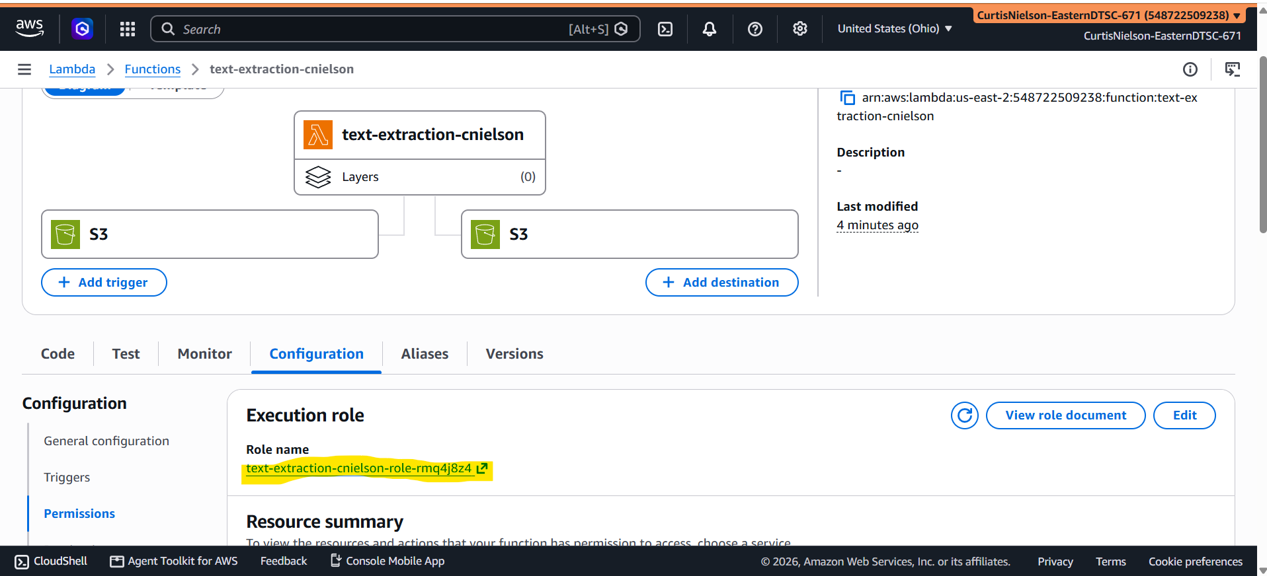
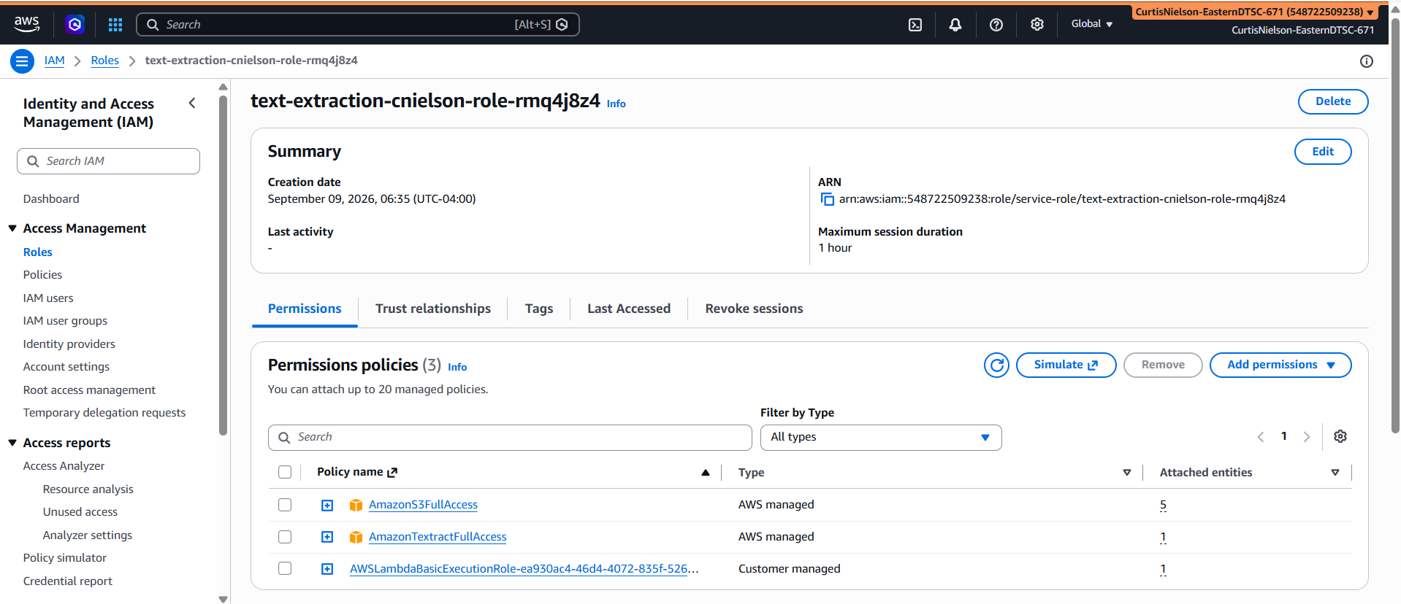

- [25 points] In the space below, provide a screenshot of the CSV file in your output bucket.
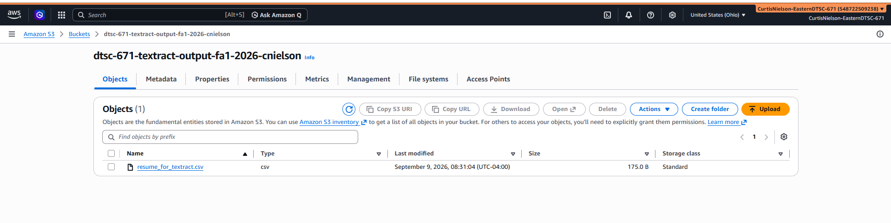

- [25 points] Provide a screenshot of your CSV file’s output (which extracted fields). Fit all of the information in the screenshot.

